

1. Open SQL Server Management Studio -> New Query File -> Open -> Datawarehouse SQLScript -> Execute.

2. Output: Sales_DW1 is added to DB

3.Open SSDT -> File -> New project -> Analysis Services Multidimensional & Dataminning -> Save the file (OLAP) -> ok.

4. Create Data Source: Right Click on Data Source in solution explorer -> New Data Source -> Welcome -> Next -> new -> Server name(.) -> Select or enter DB name (Sales_DW1) -> Test Connection -> Ok ->Next -> Impersonation Information Window Open-> Inherit -> Next -> Data Source Name:Sales DW1 -> Finish.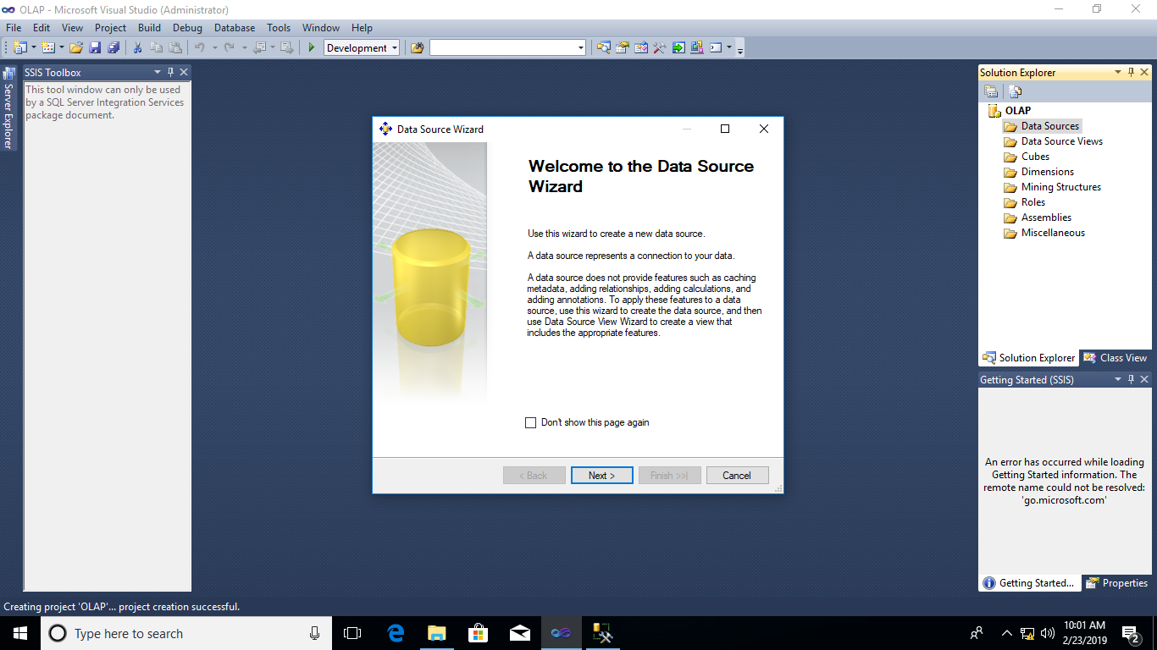

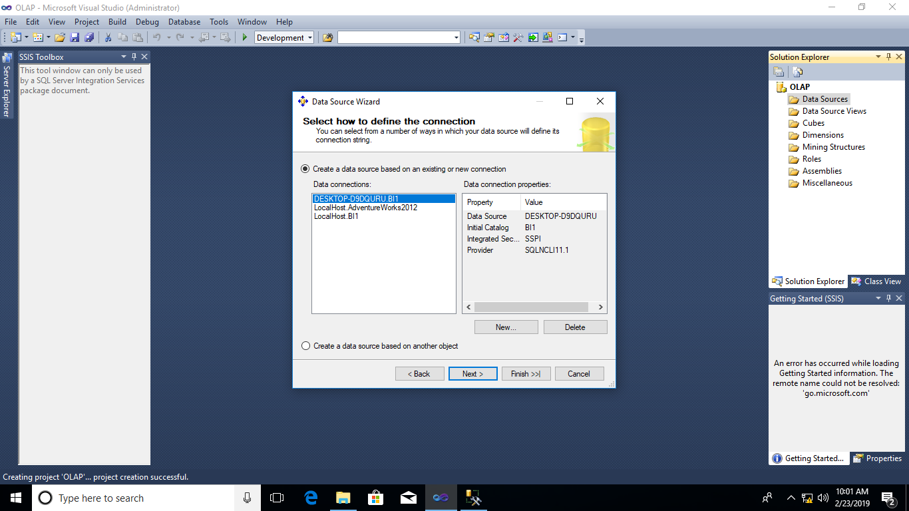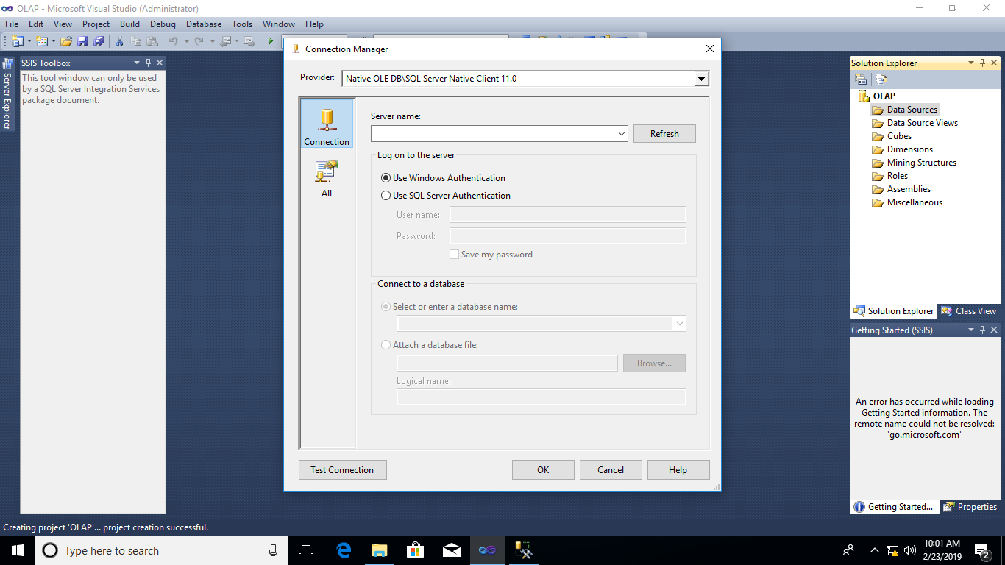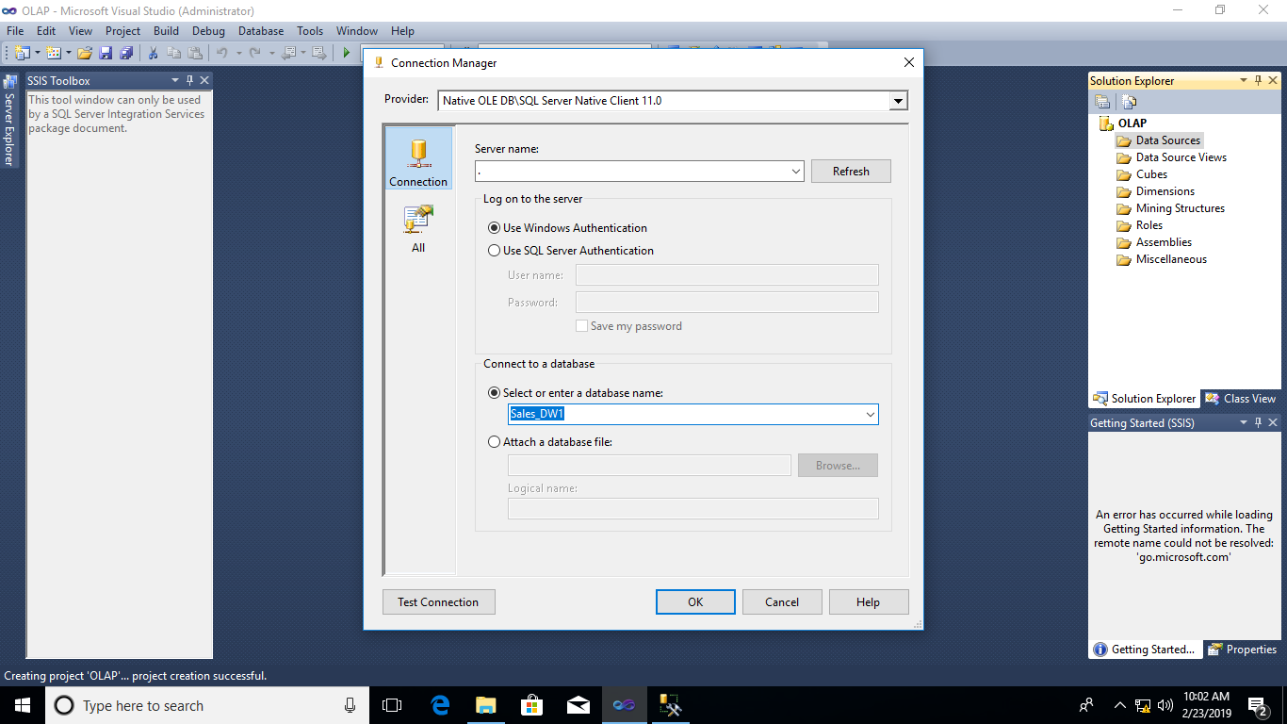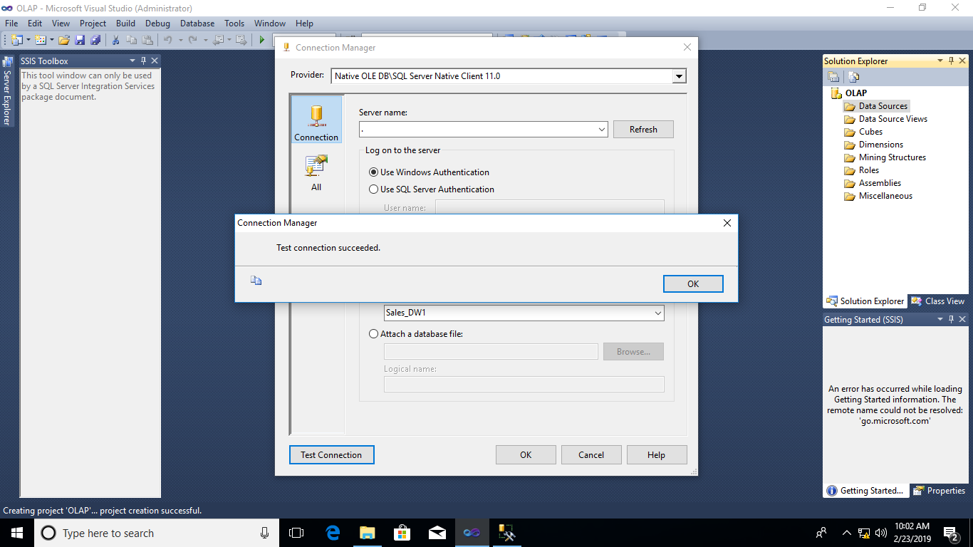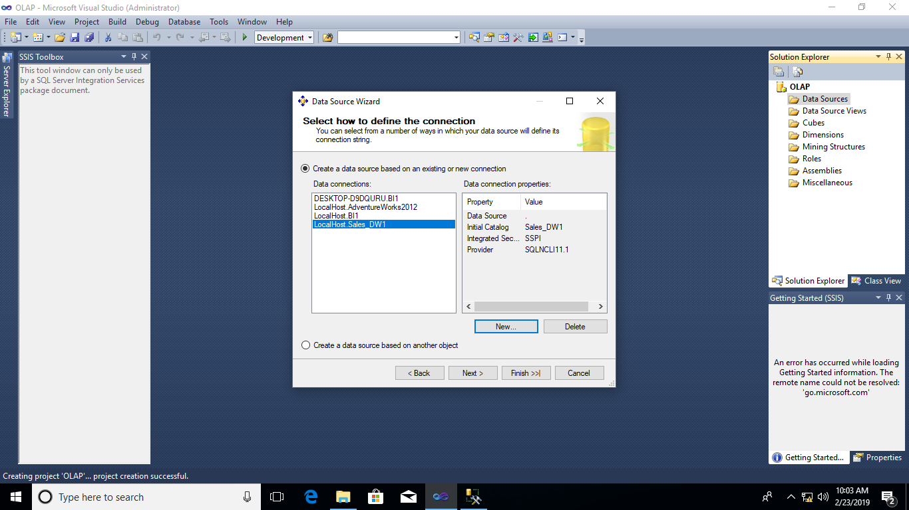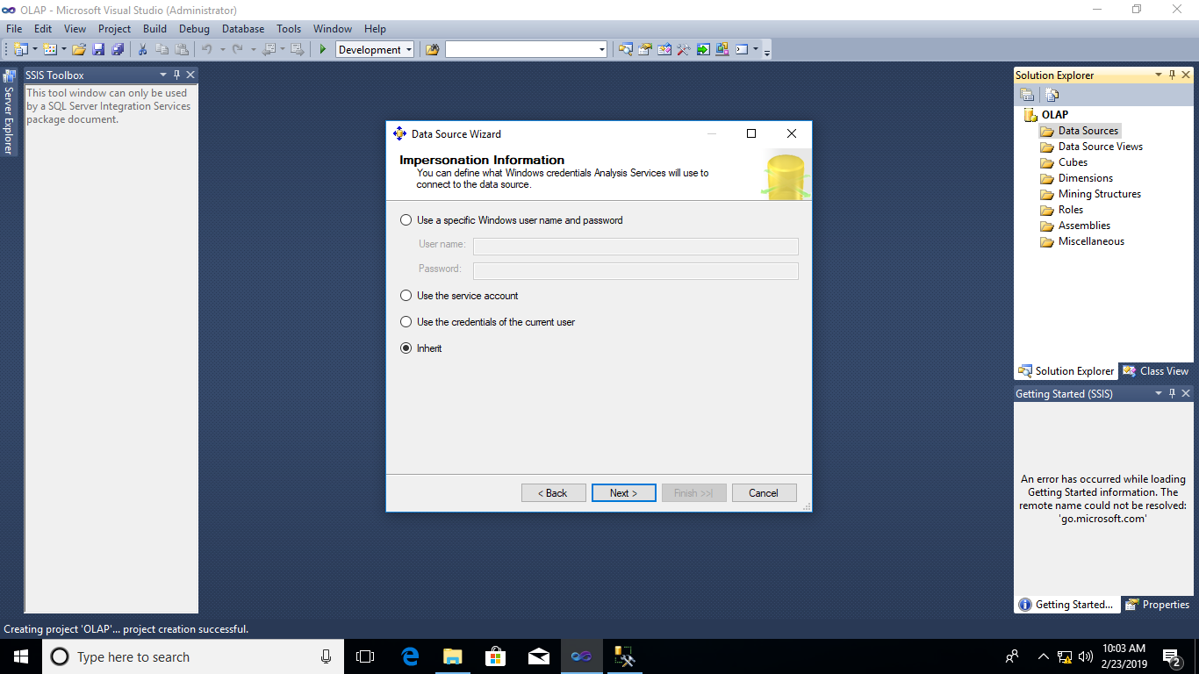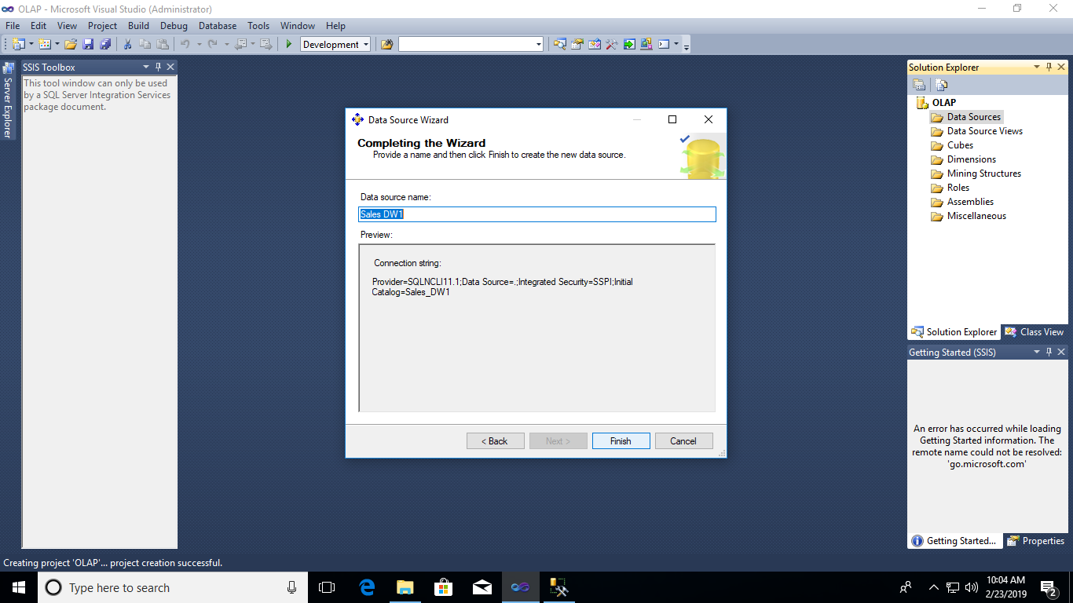

5. Create DataSource View: Right click on DataSource View -> new -> select the DataSource window -> Sales_DW1 -> next -> select tables and views window open -> FactProductSales -> click on ">" -  
> add related tables -> next -> completing the wizard windows -> Finish

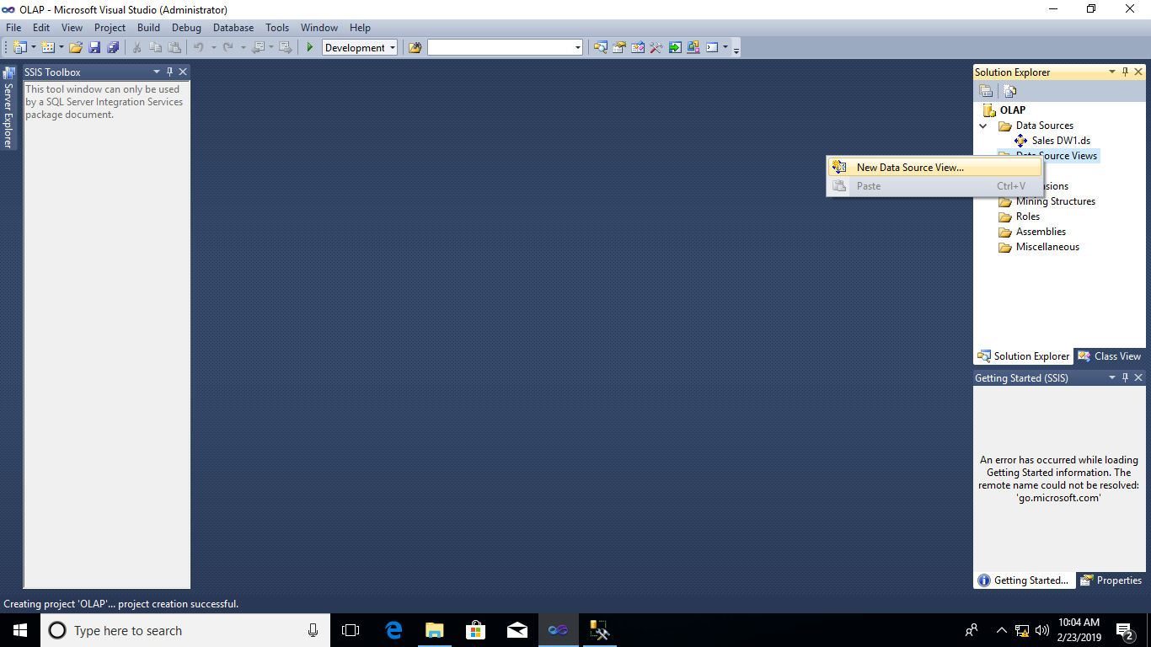

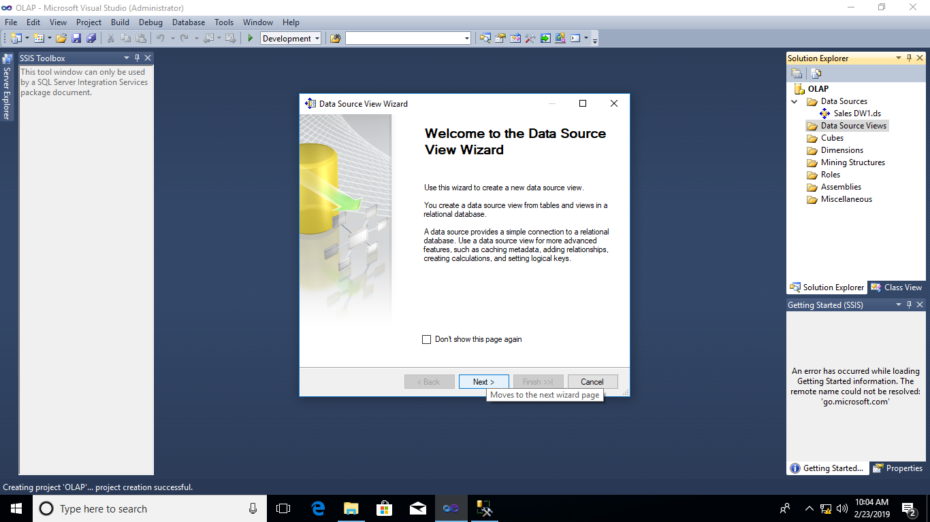

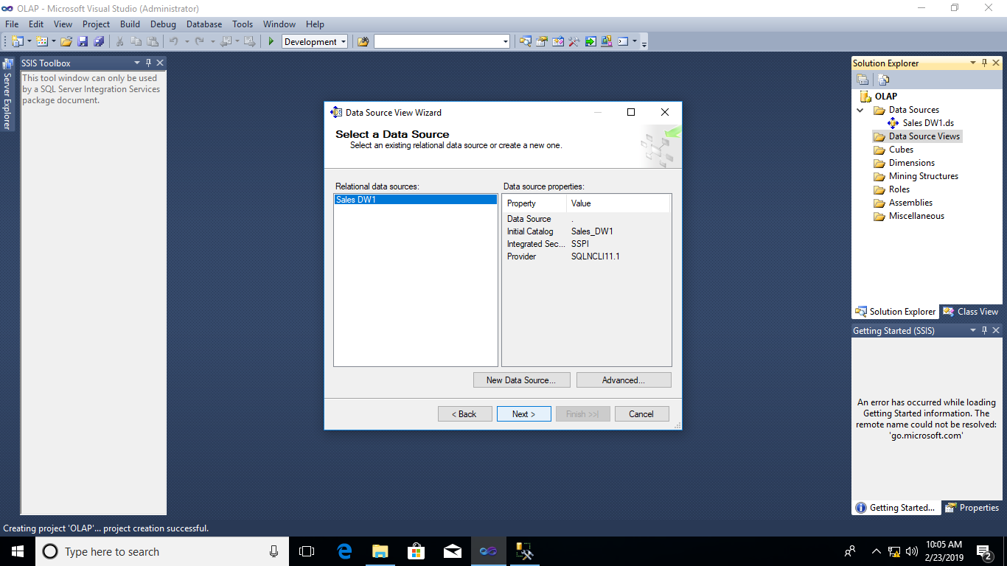

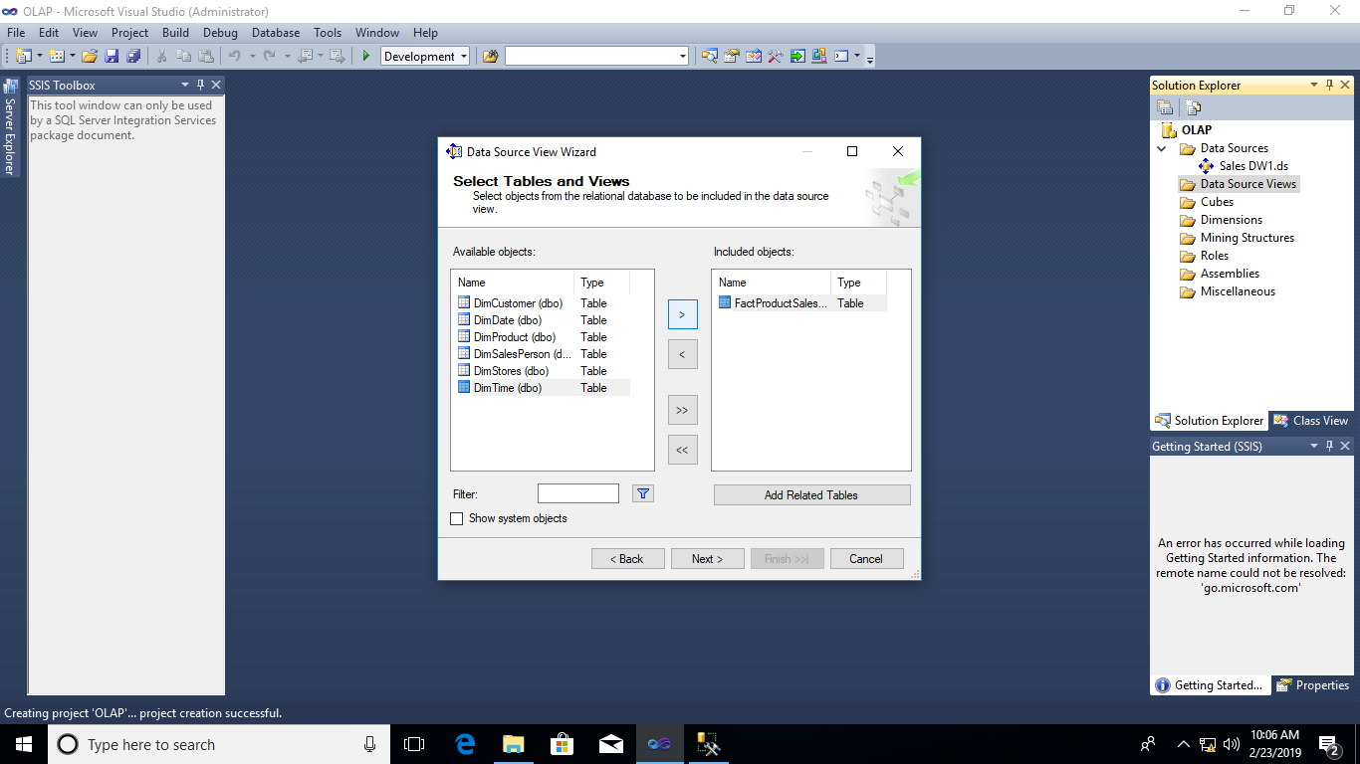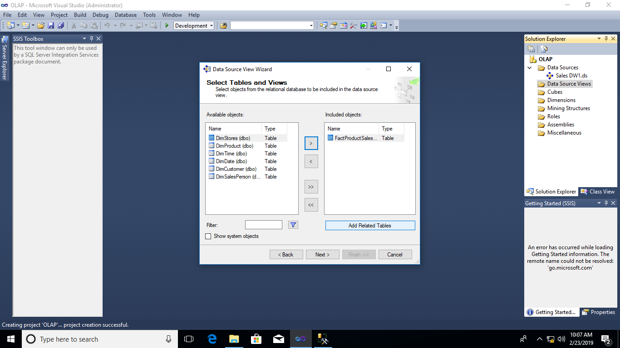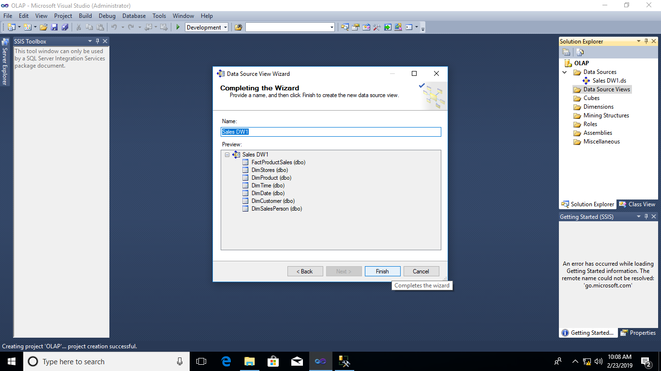

6. Output: Star Schema is obtained with fact table in center and dim tables around.

7. Create Cube: Right click -> cube -> new cube -> next -> select creation method window opens -> Use existing tables -> next -> select measure group tables -> select DataSource View (Sales DW1)-> select measure group tables (FactProductSales) -> next -> Select measures window will open -> select all measures needed -> select new dimension -> select all dimensions -> Completing the wizard window -> Finish.

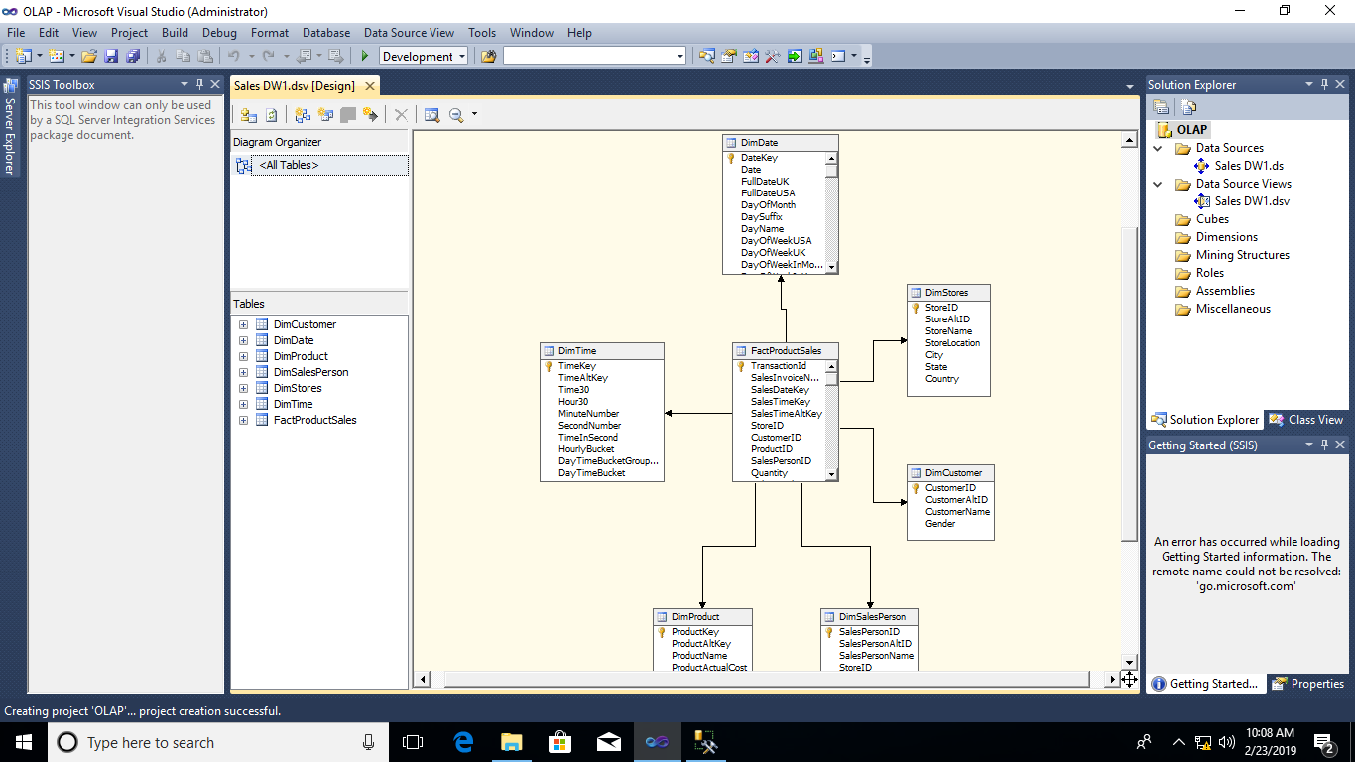

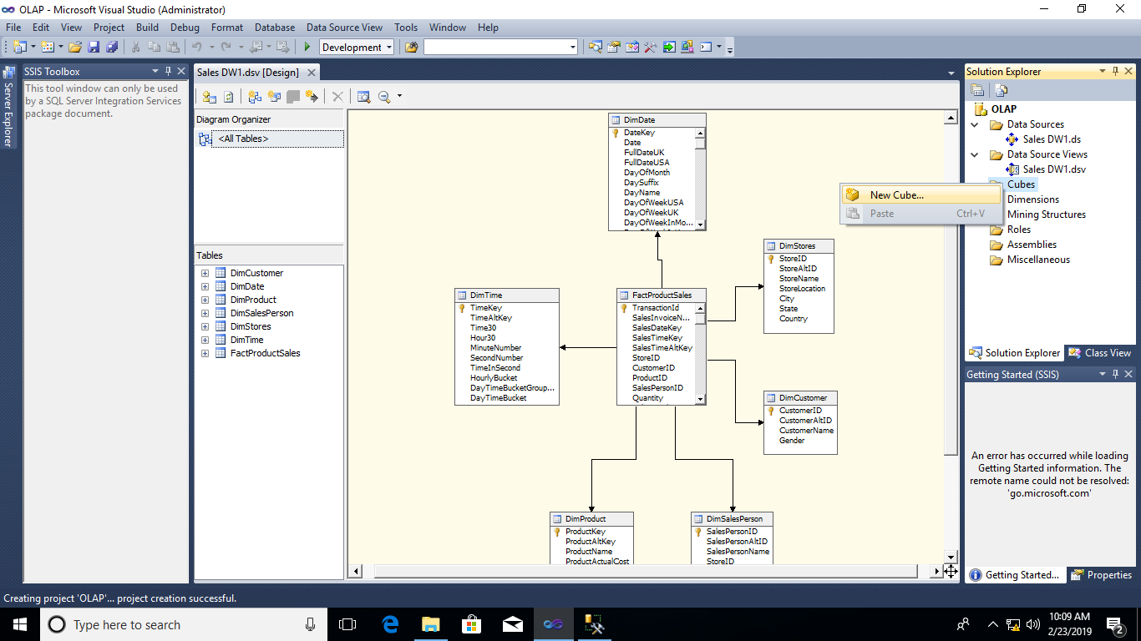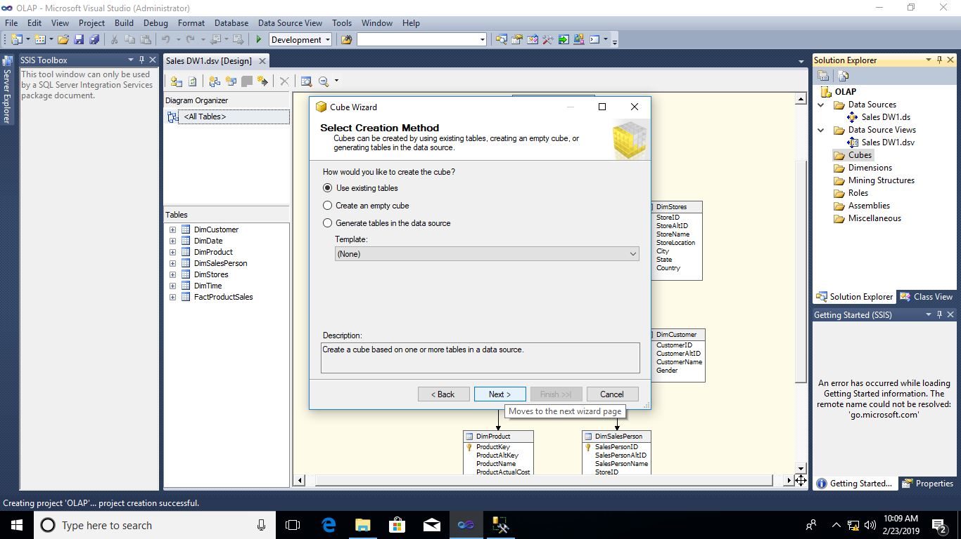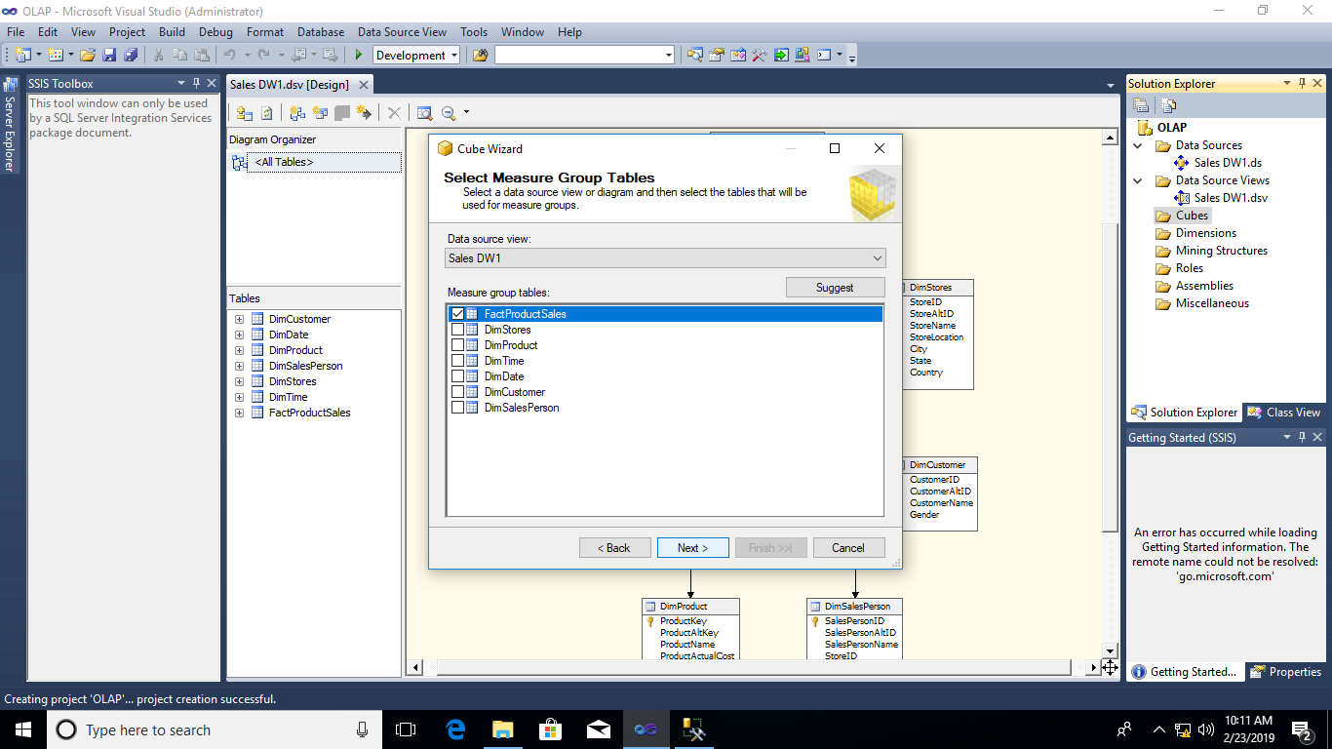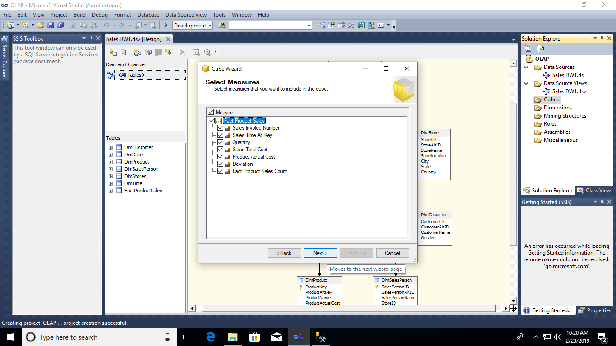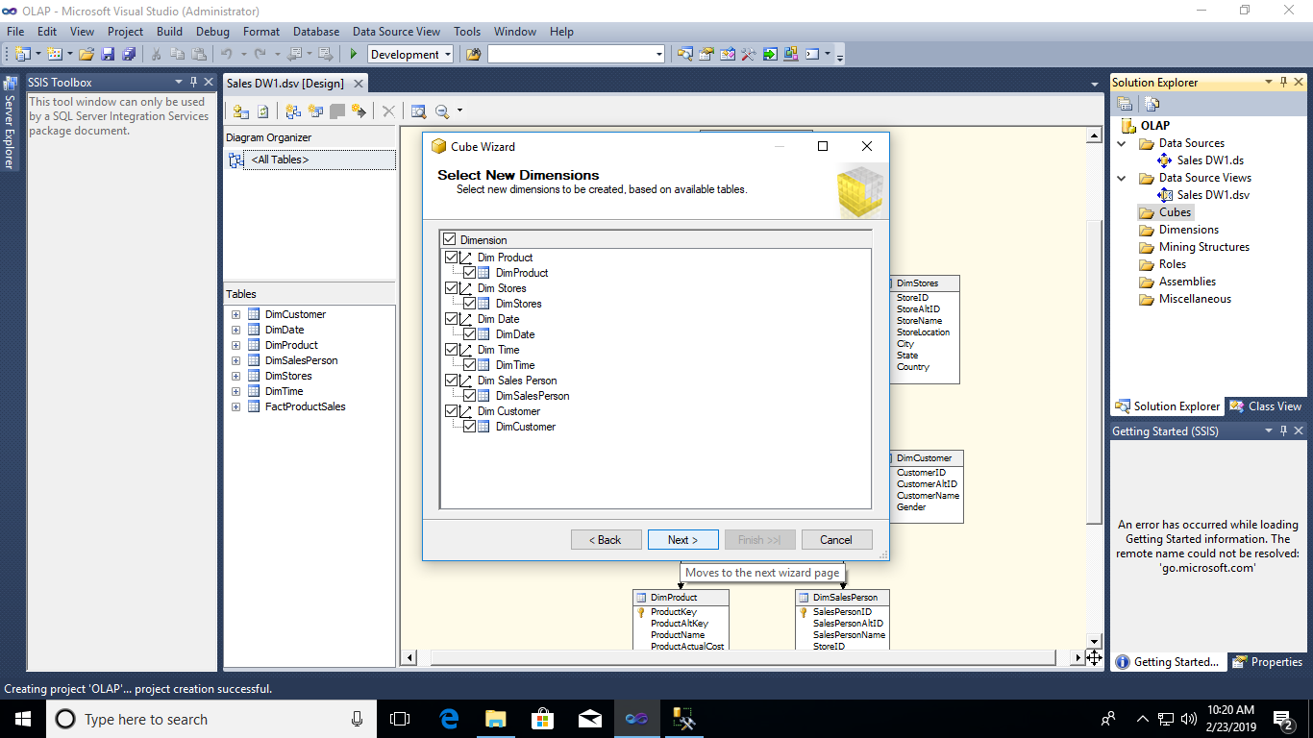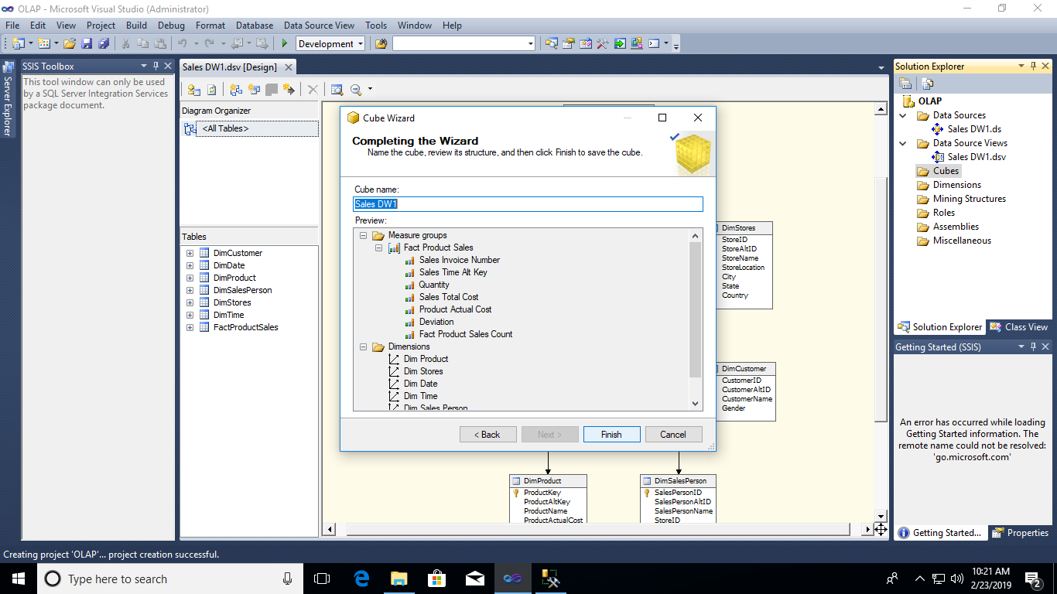

8. Output: Cube and Dimensions are added in respective tab.

9. Double click on Dimension tab -> DimProduct.dim

10. Drag and drop on DataSource view to attributes -> Double click on DimDate.dim

11.Attributes:-Year,QuarterName,MonthName,WeekofMonth,Fullde UK.

12. Hierarchy :- Add from attributes to hierarchy by drag and drop in same order.

13. Deploy cube :- right click on OLAP -> properties-> deployment

processing options - do not process

Transactional deployment- False

server mode- deploy all

target

server localhost

Db OLAP

apply-> OK

14. Right click on project name(OLAP) -> deploy

output-> DEPLOYMENT SUCCESSFULLY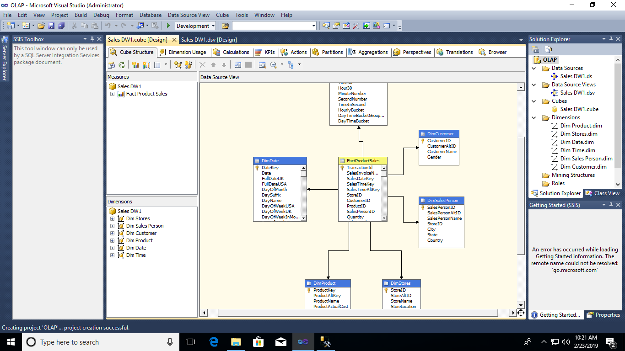

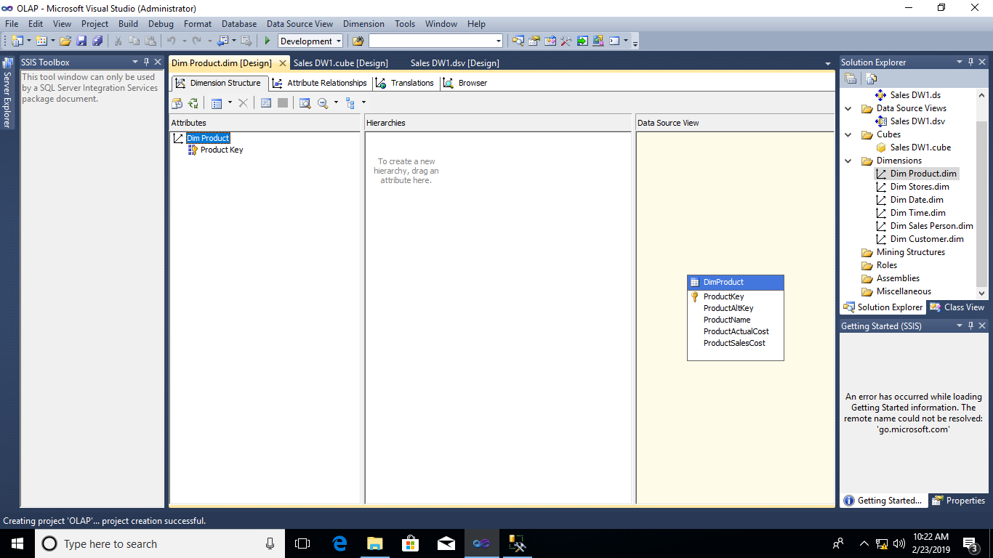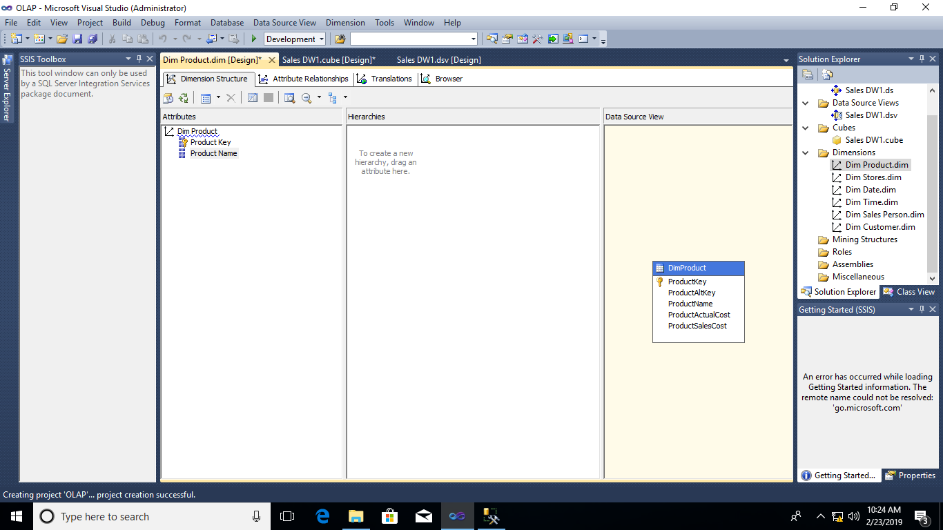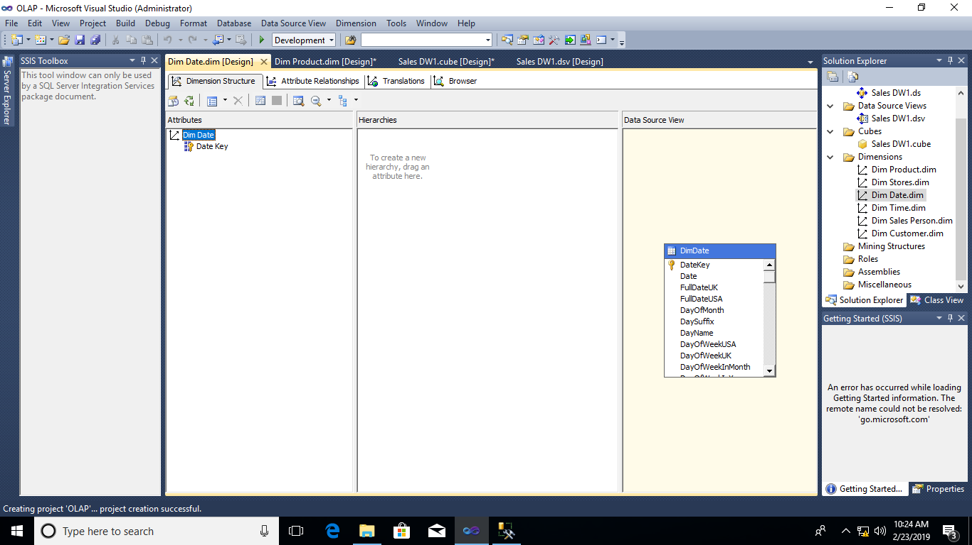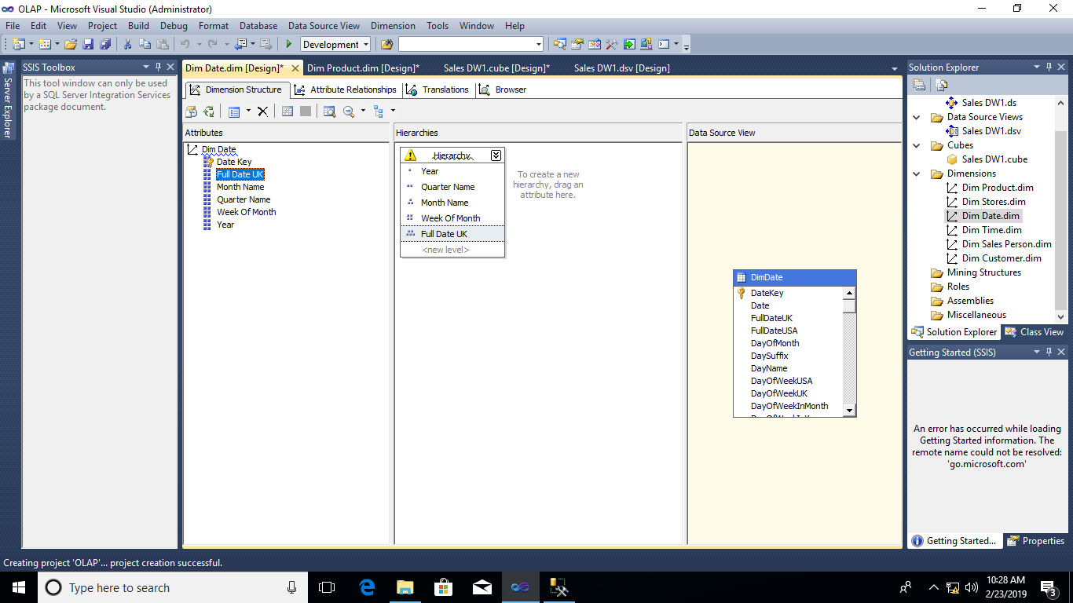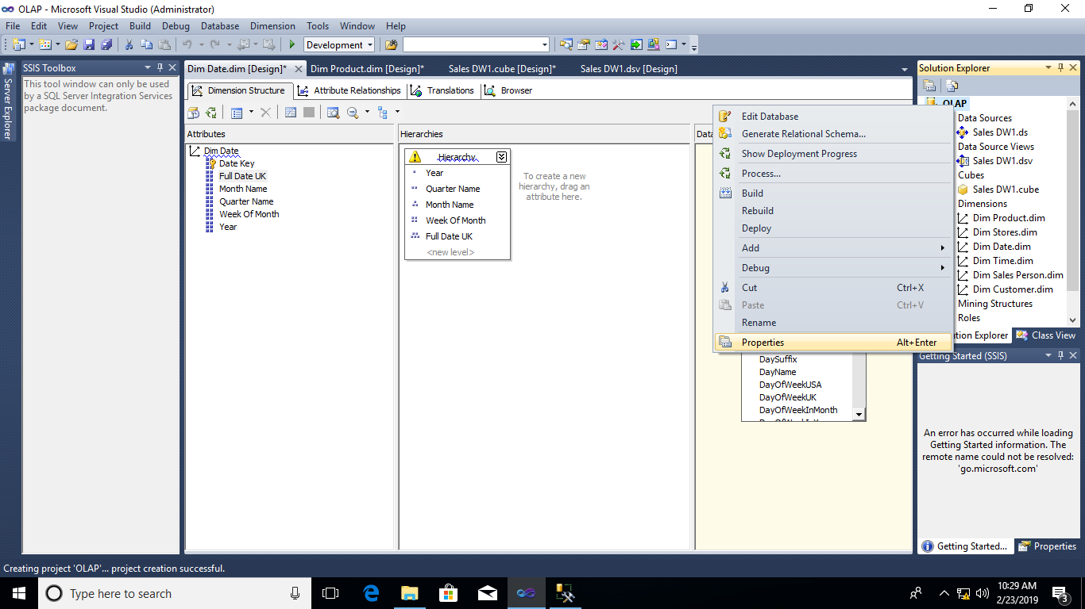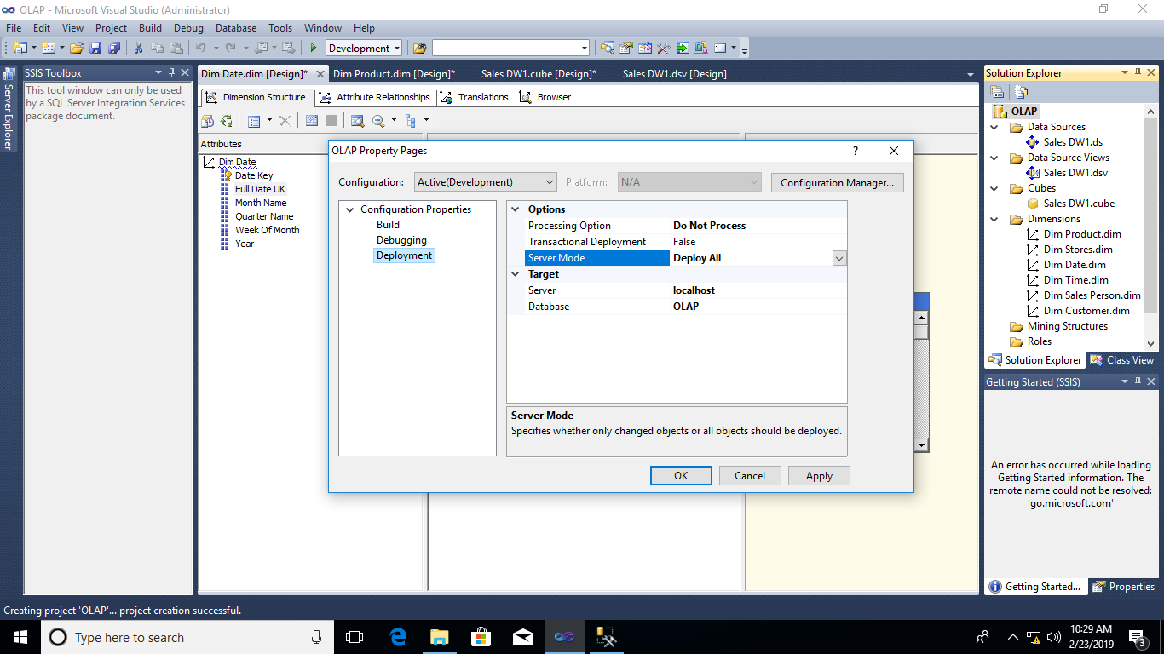 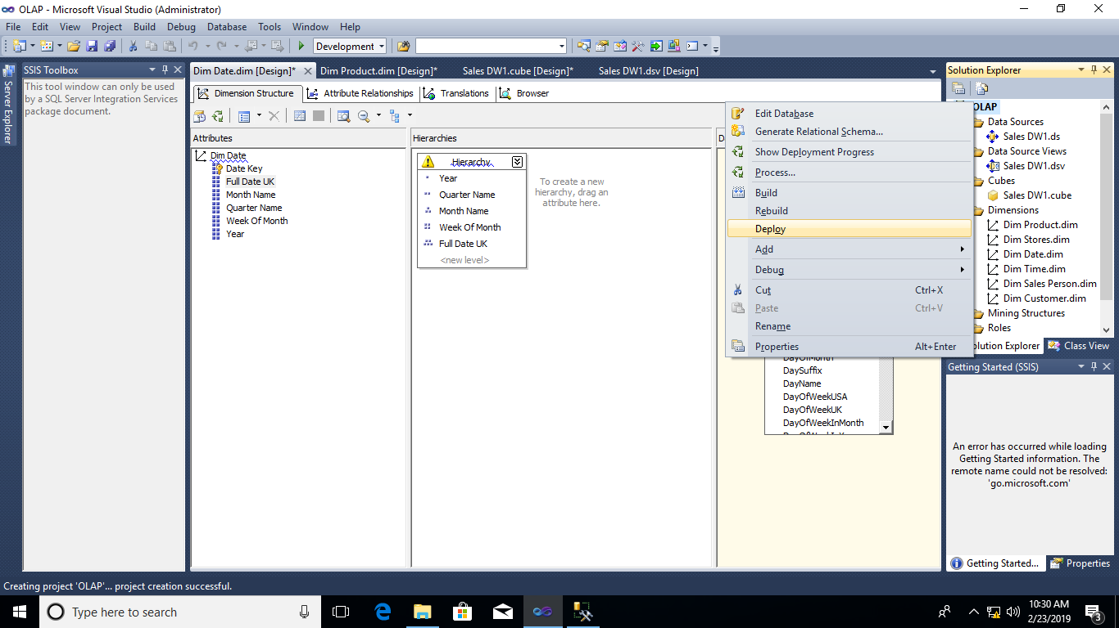

15. Process cube: Right click on cube(Sales_DW1)->process -> run

If error occurs :-

SQL management studio-> security ->logins-> new login-> login name : NTService\MSSQL serverOLAPservice-> default database - salesDW1 -> on left pane -> user mapping-> select Sales_DW1 -> database role membership for:

Sales_DW1: select db_datareader-> OK

Again run the cube

